Task on load balancers

- Configure Classic Load balancer.
Create Load Balancer
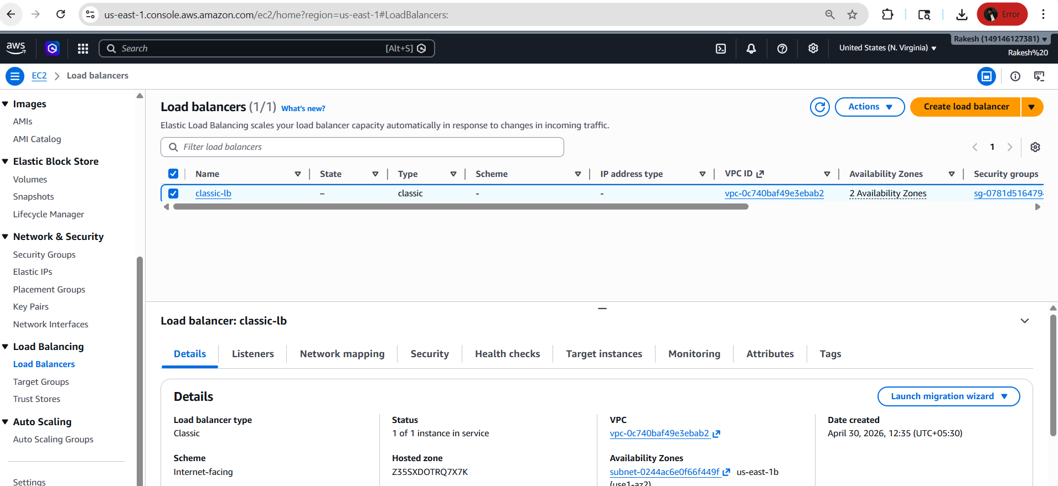
Created load balancer
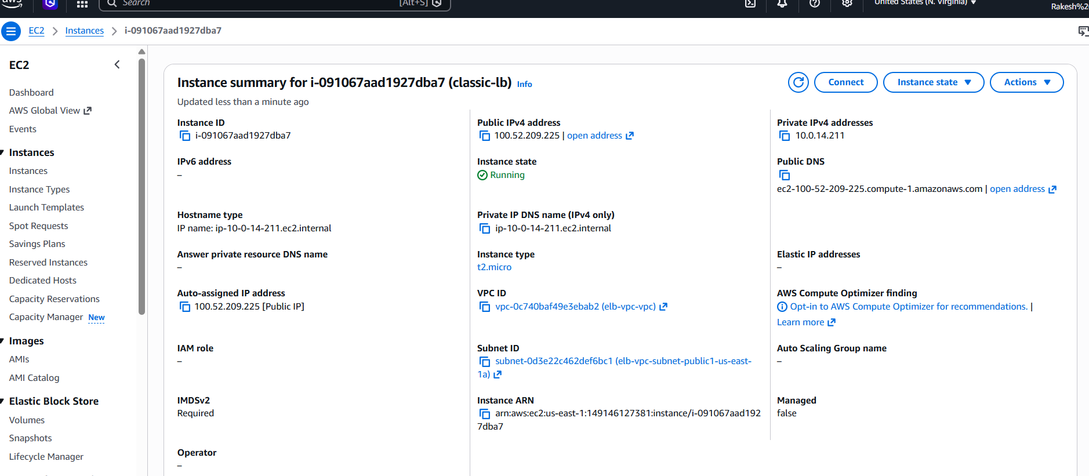
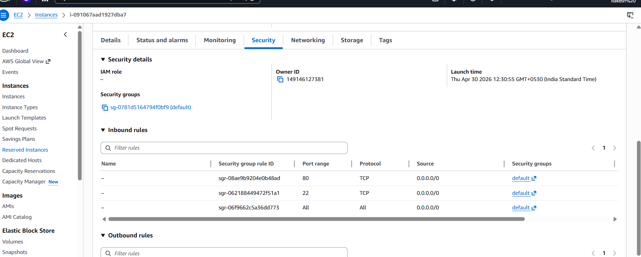
Connect to instance
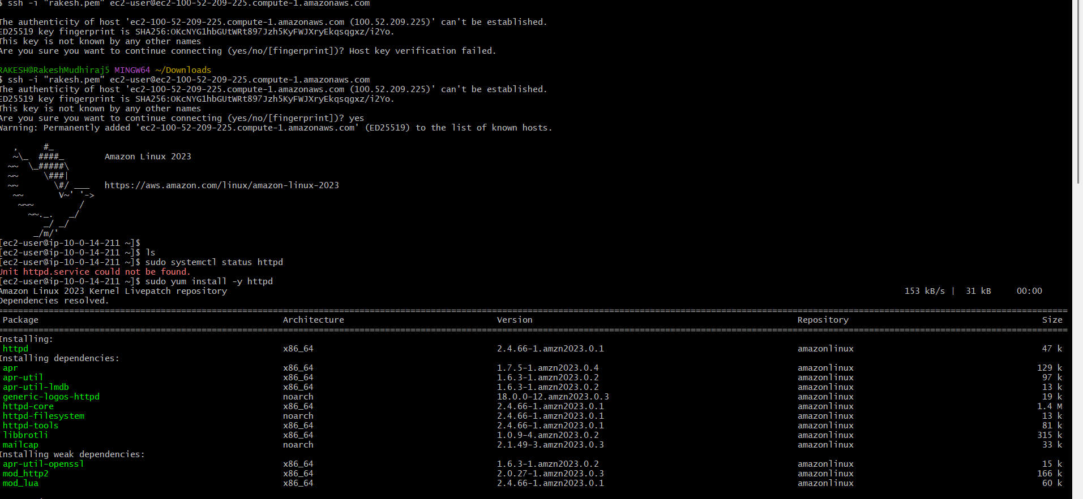
Install httpd and go to default location of httpd then give permissions &execute
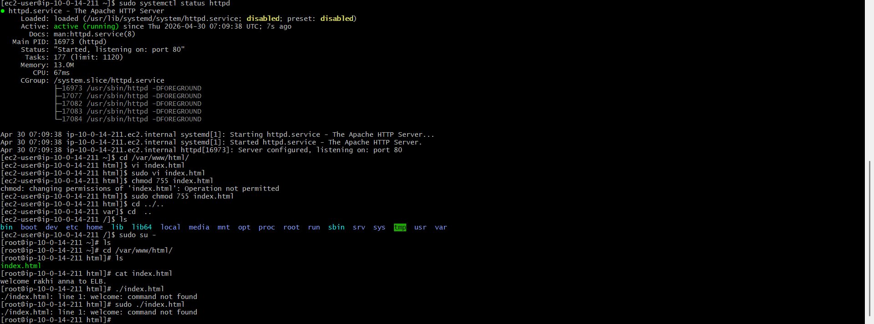
- After creation, copy the DNS name
- Paste it into your browser
- You should see your web application

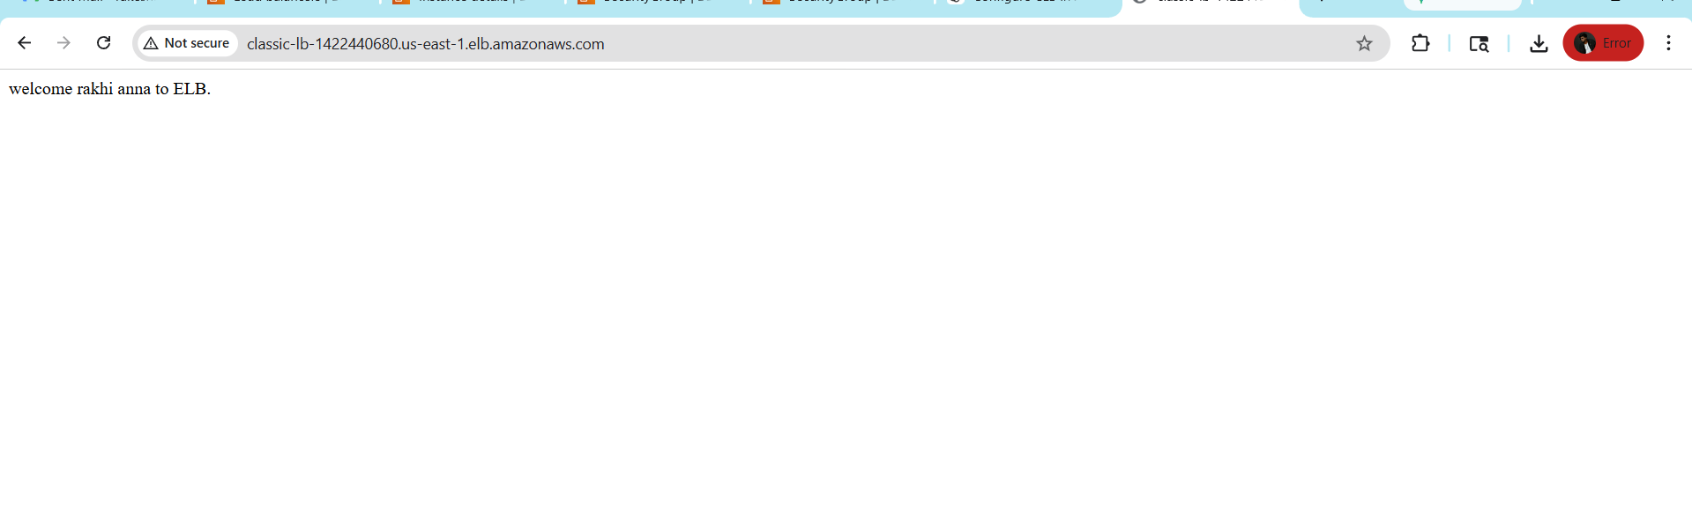
- Configure Application Load balancer.
Create application load balancer and attach target group
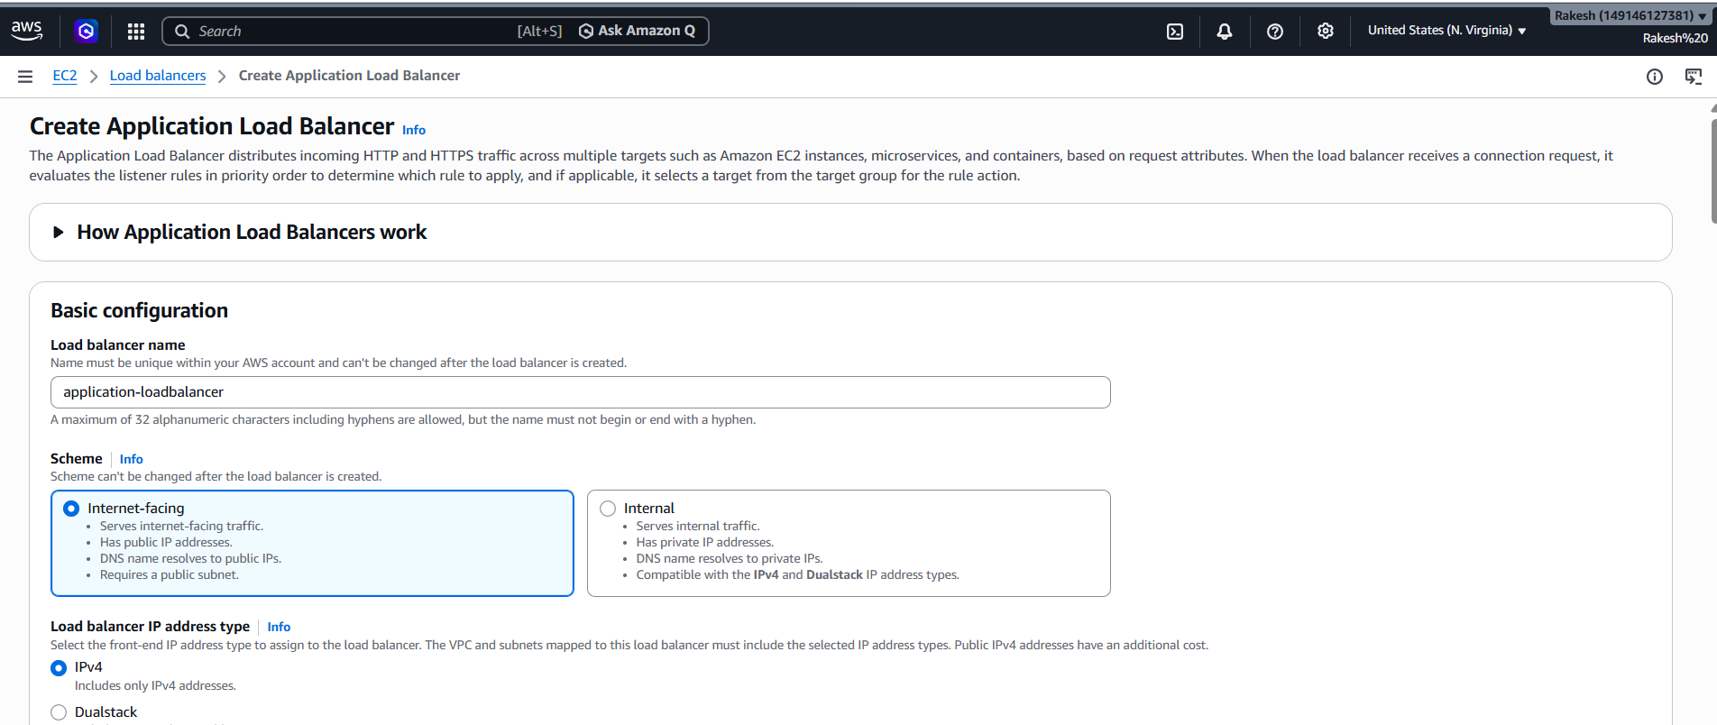
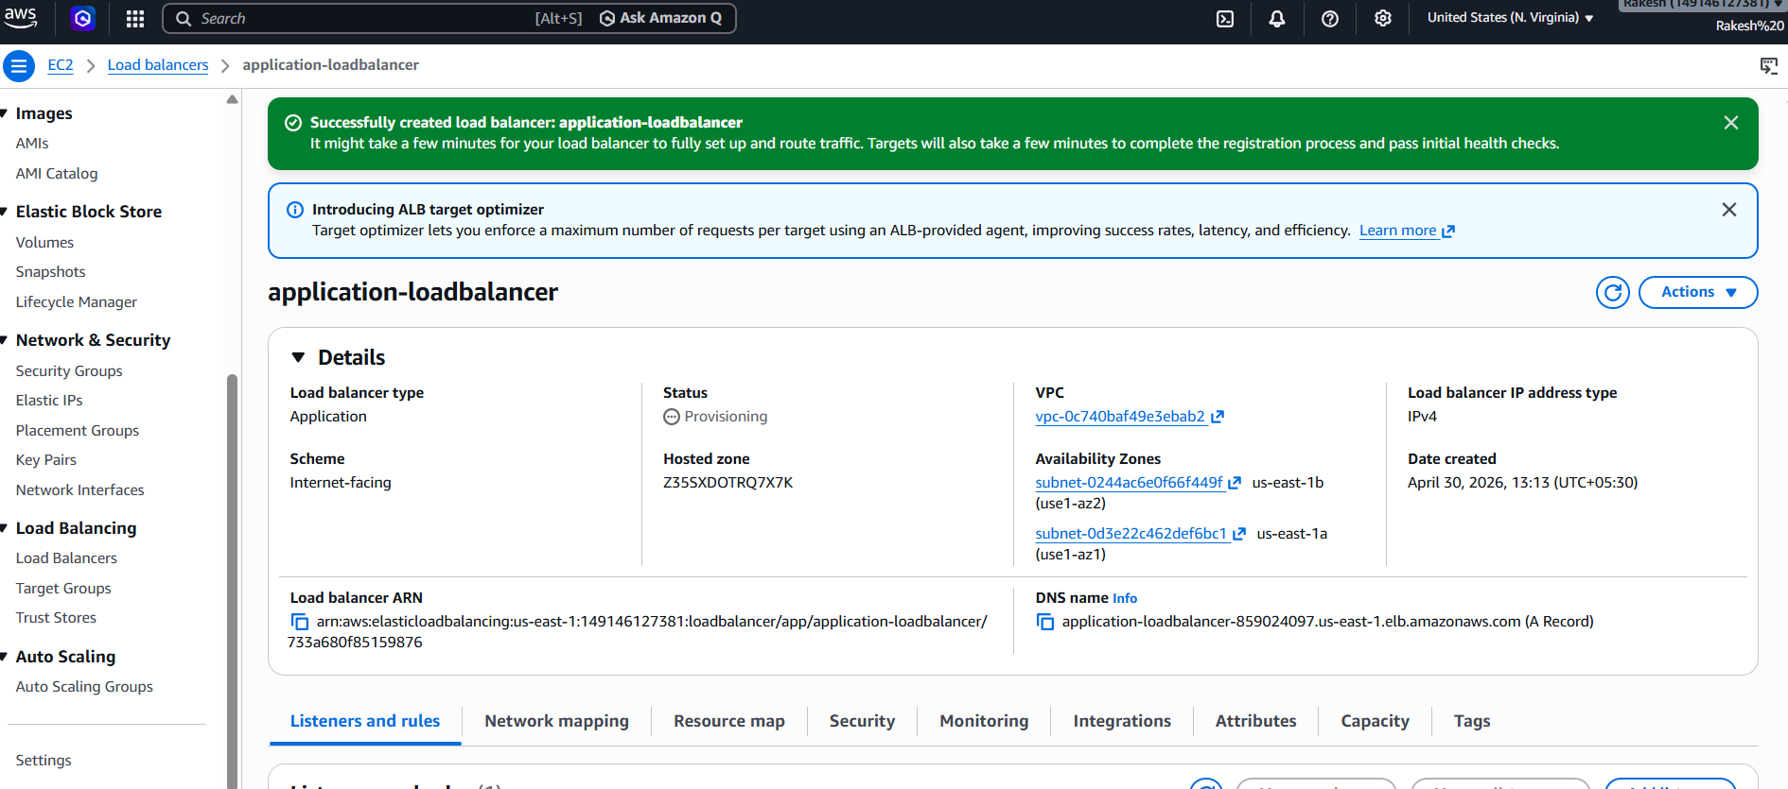
Created target groups
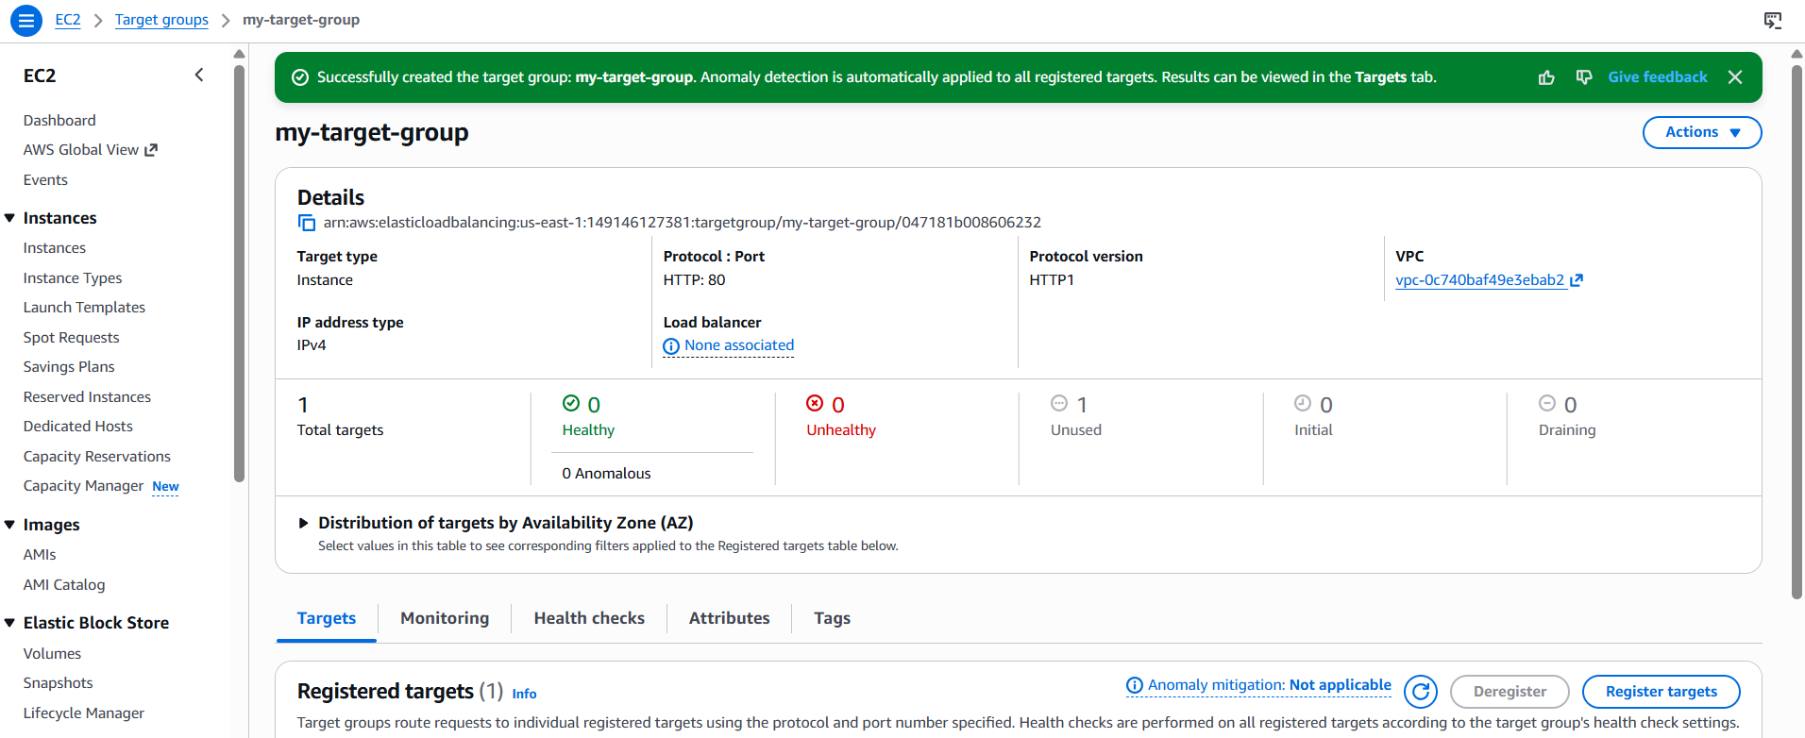

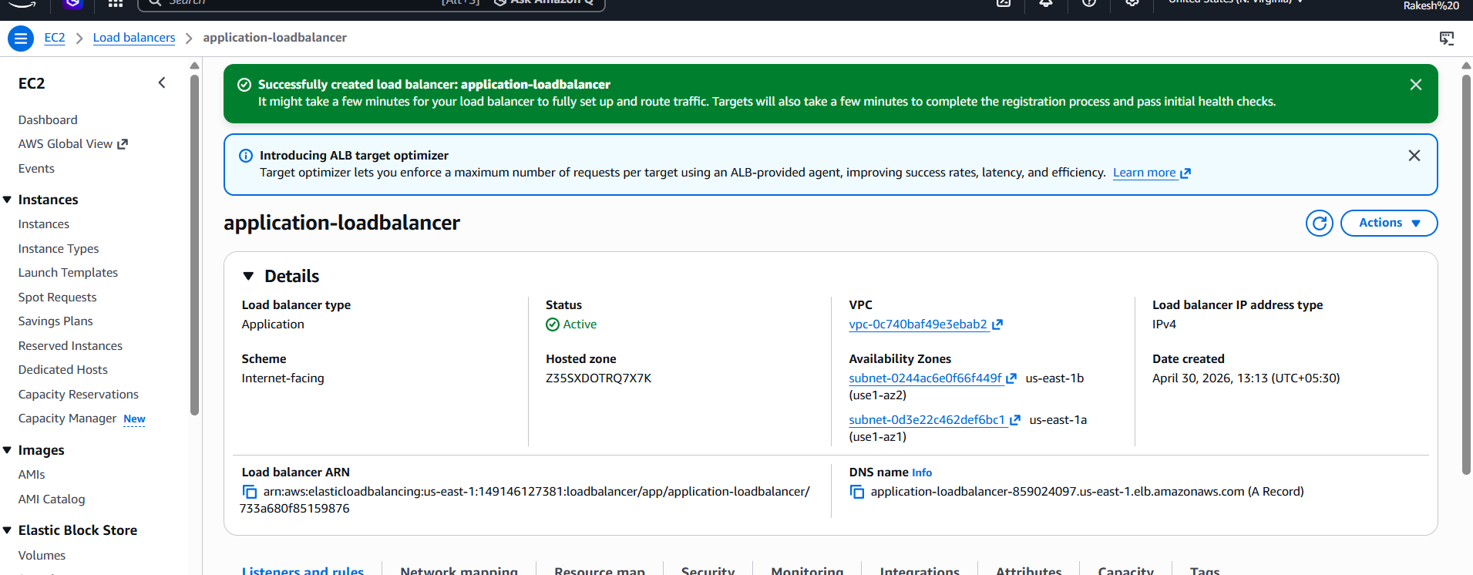
- Copy the DNS name of ALB
- Paste it into browser
- You should see your web app
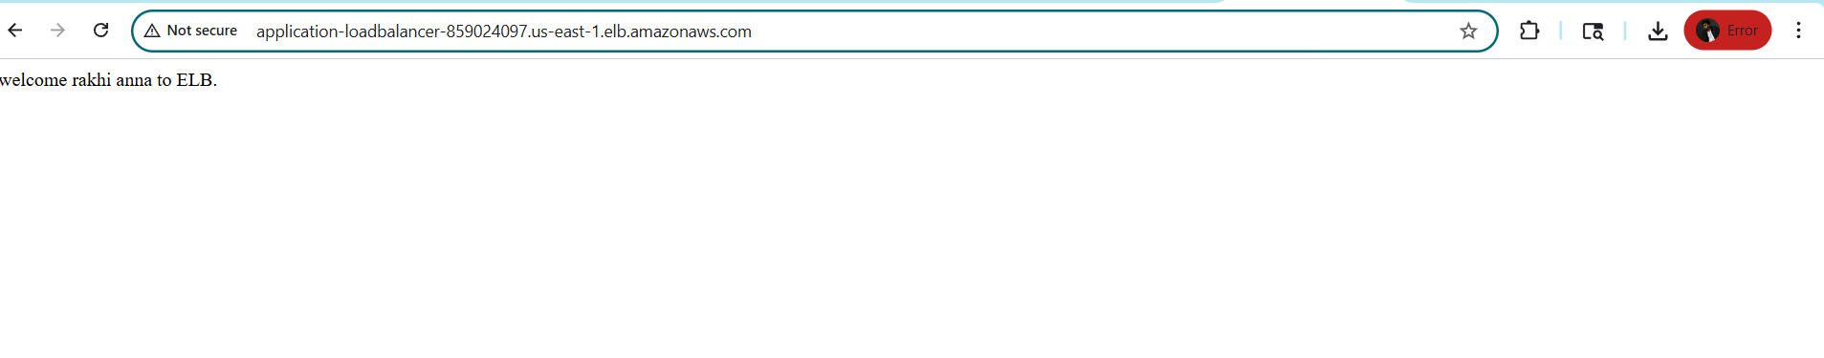

- Configure Network Load balancer

Create Network Load balancer
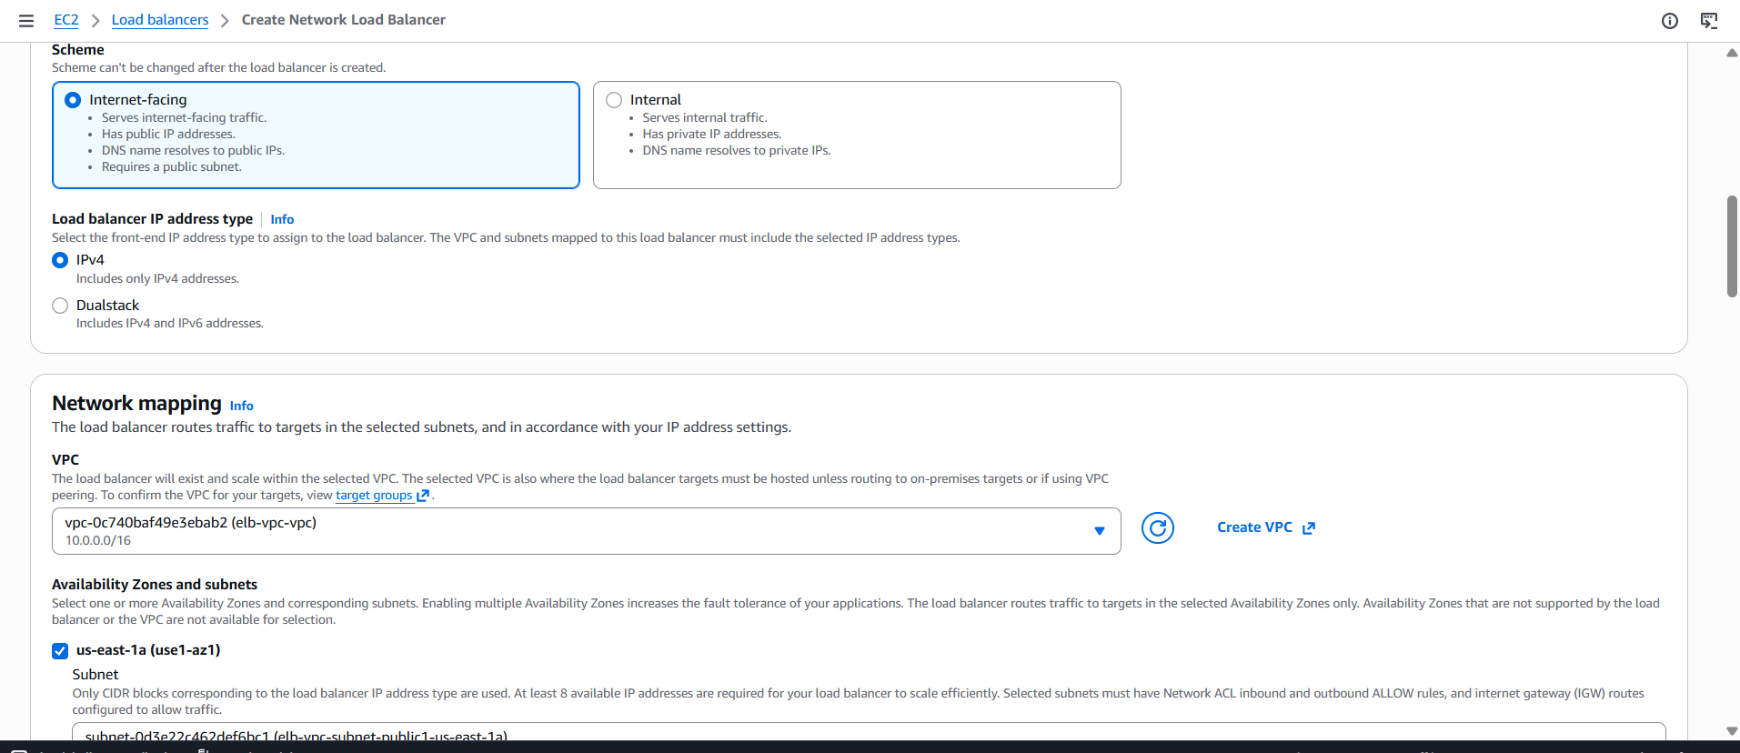
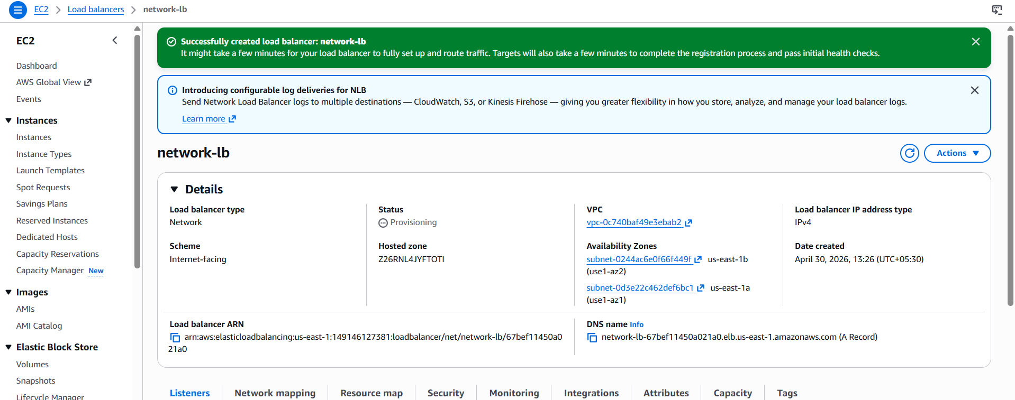

CREATED TARGET GROUPS
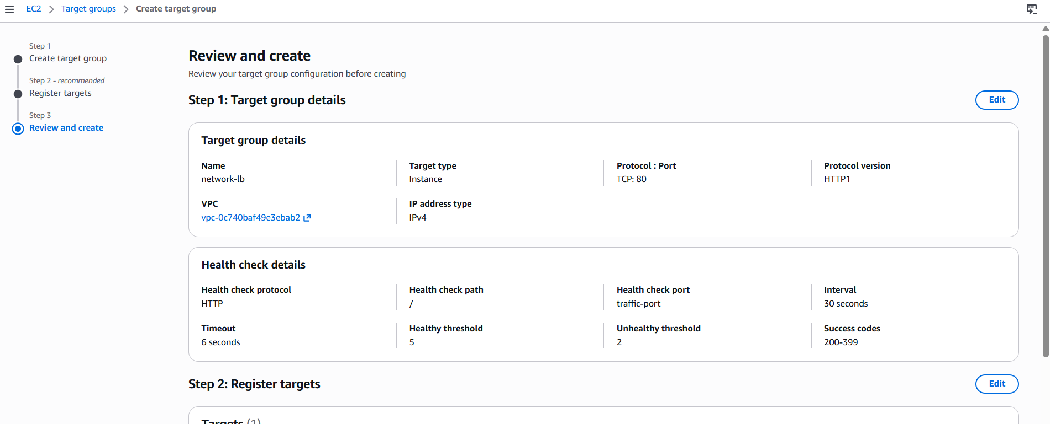
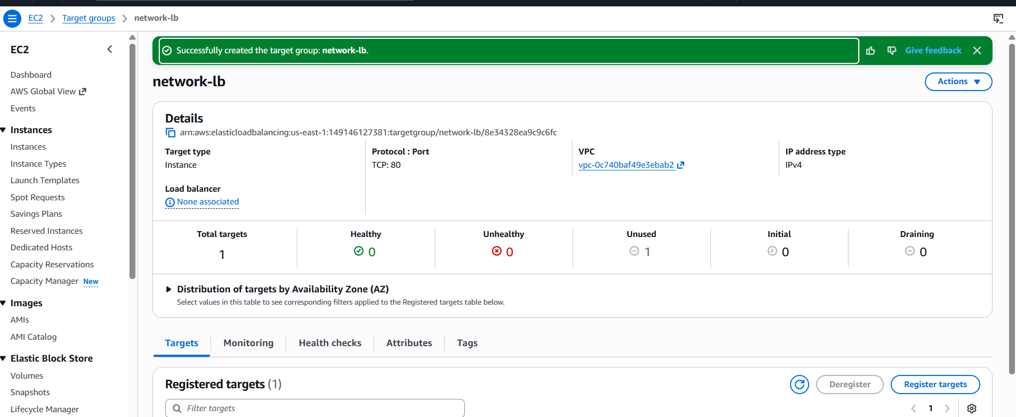
- Copy the DNS name of ALB
- Paste it into browser
- You should see your web app

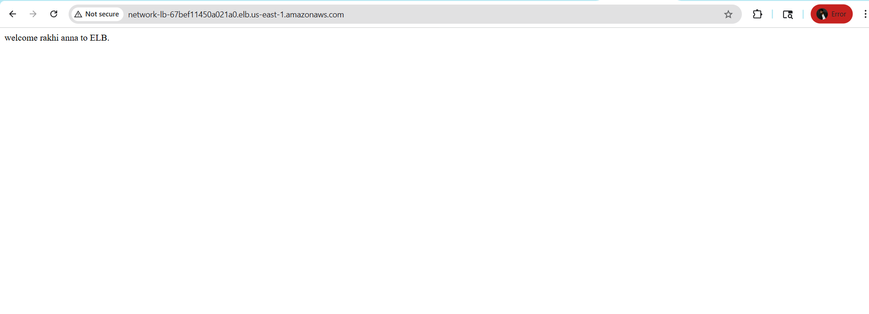

- Attach SSL for application load balancer.

Create a ssl certificate with dns validation and public
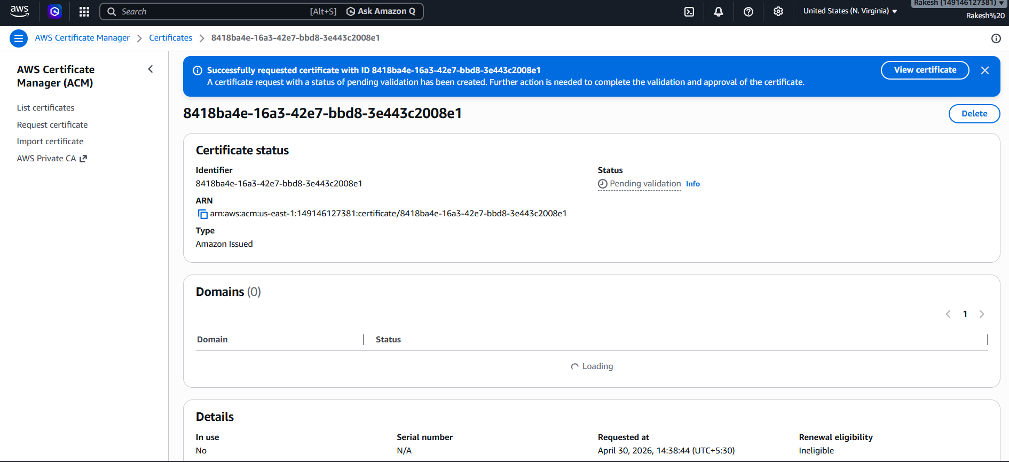

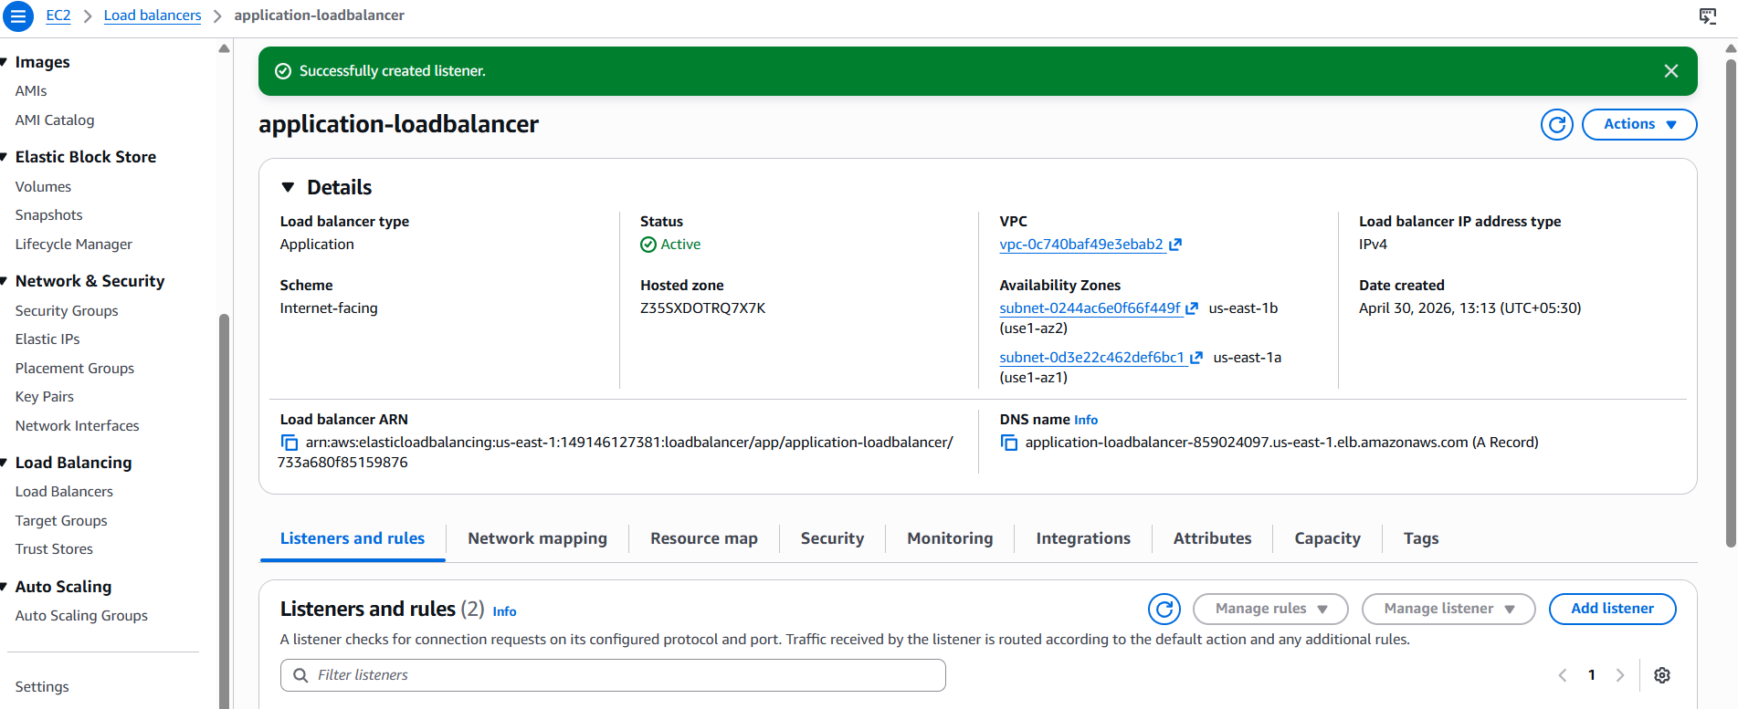
Add HTTPS Listener :443 and add ssl certificateand Configure Routing

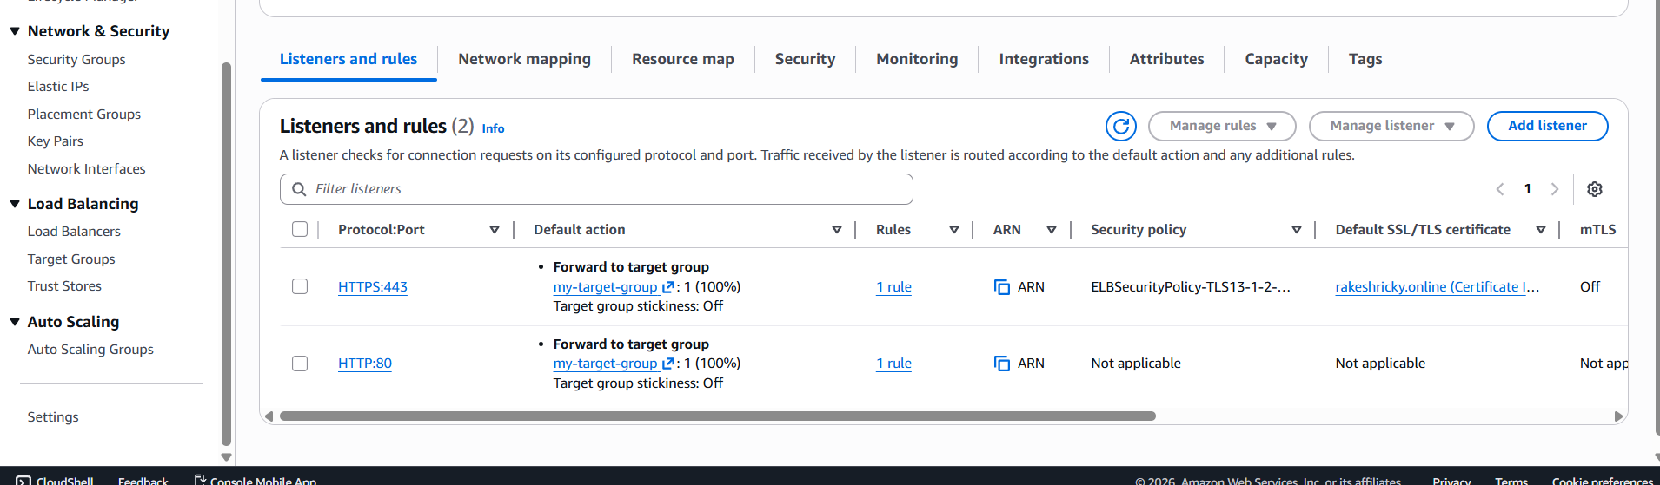
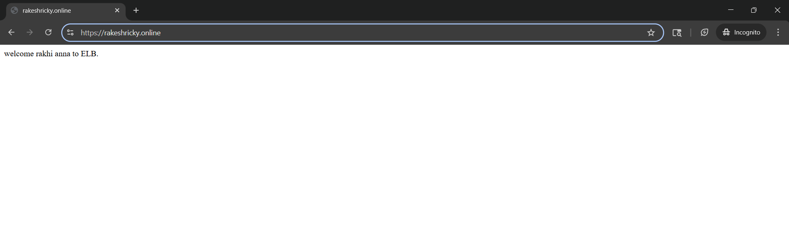

- Map Application load balancer to R53.
Route 53 to hosted zone to create a record
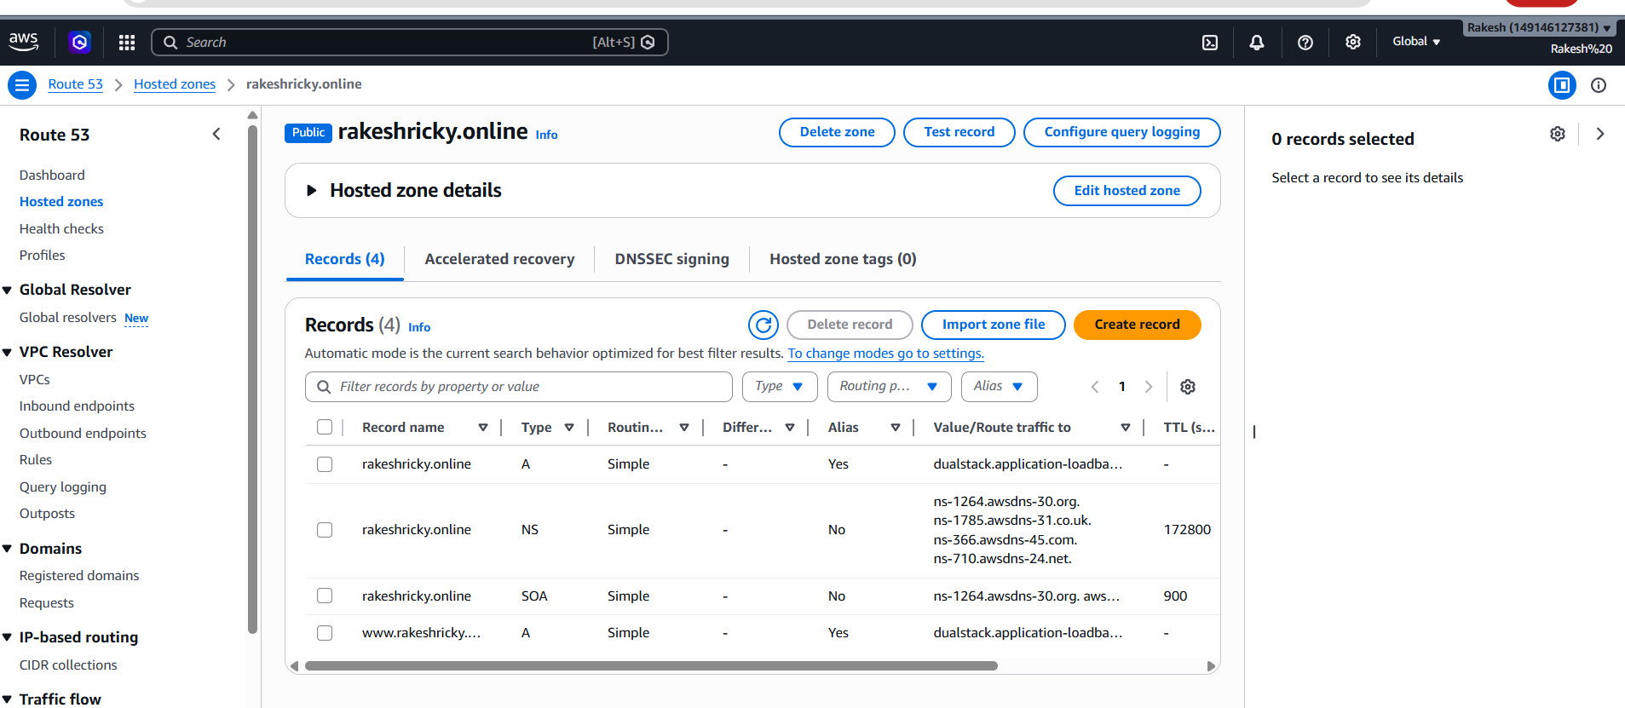
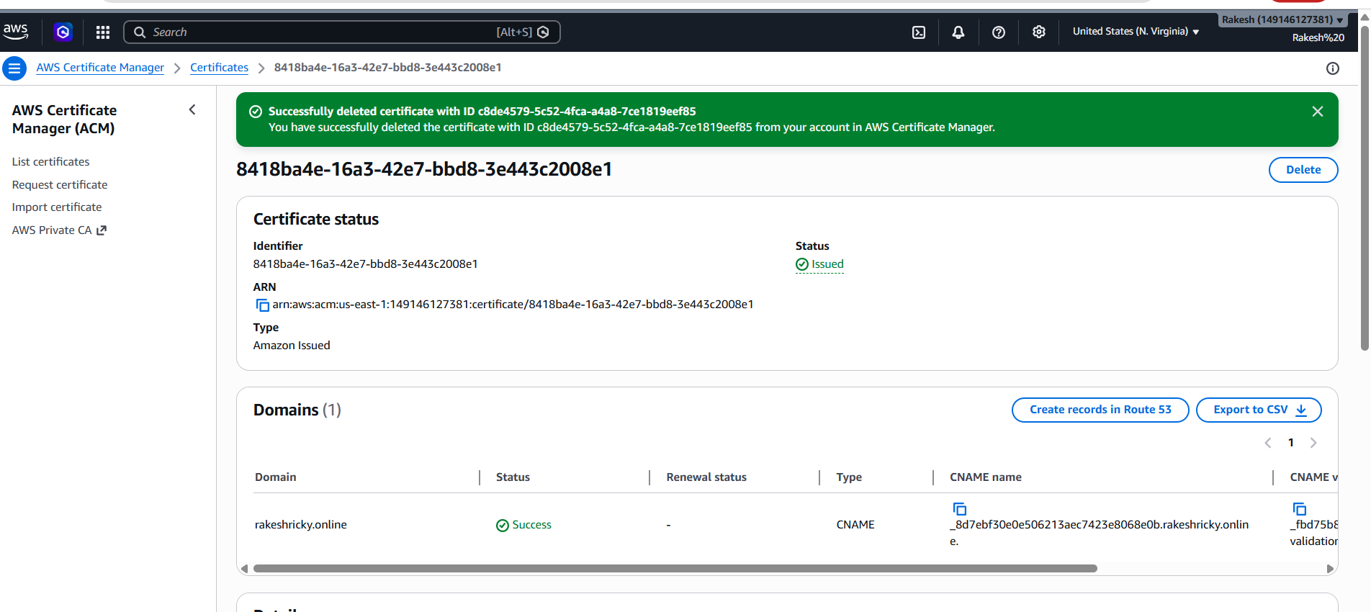
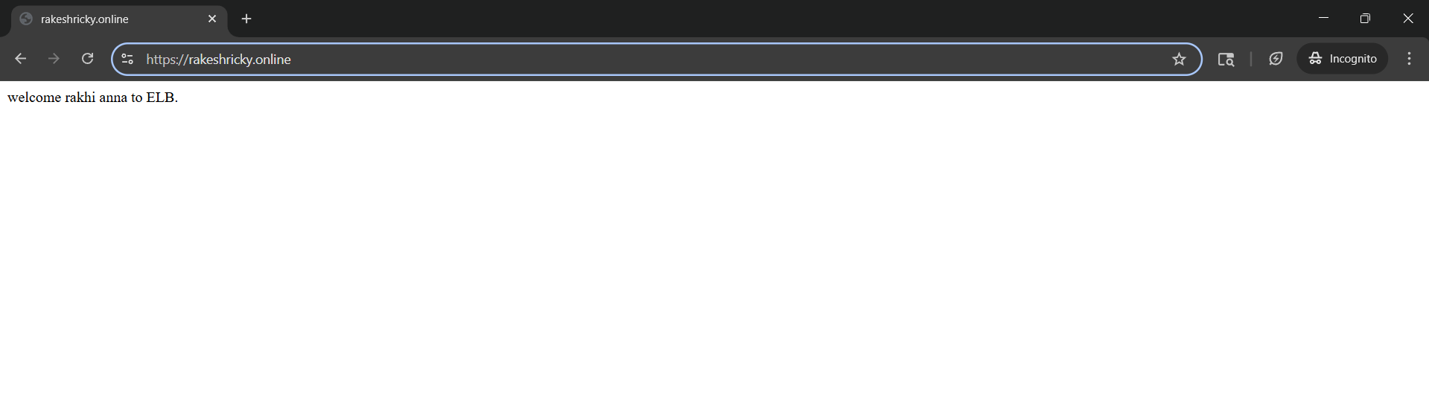
- Push the application load balancer logs to S3.
Created bucket
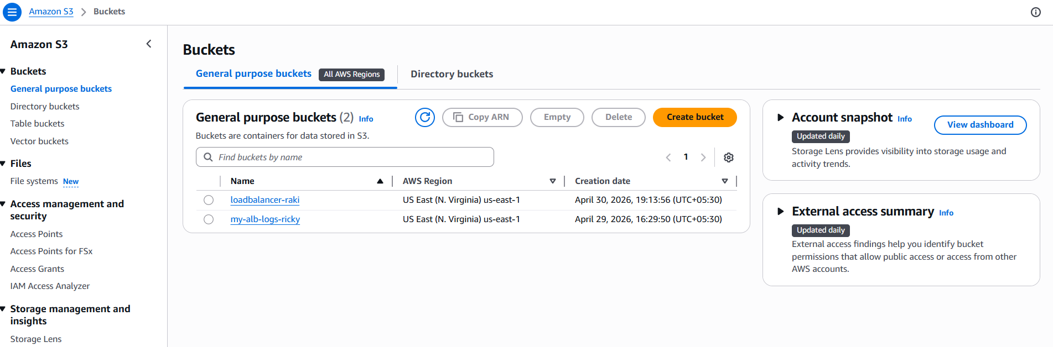
Goto Application load balancer click on Attributes your able to see last→ →
monitoring option click on access logs browse your bucket and selct save→ → →
changes 